cml0081@auburn.edu COMP 5660 Fall 2020 Assignment 1a

Graph for problem set a1:

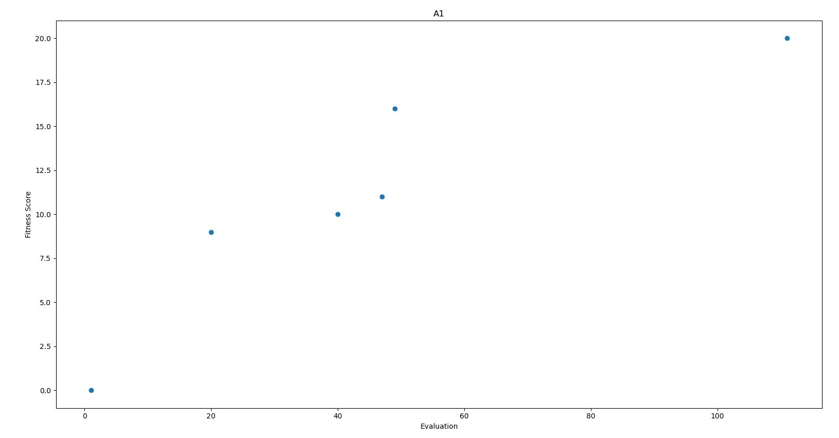

Graph for problem set a2:

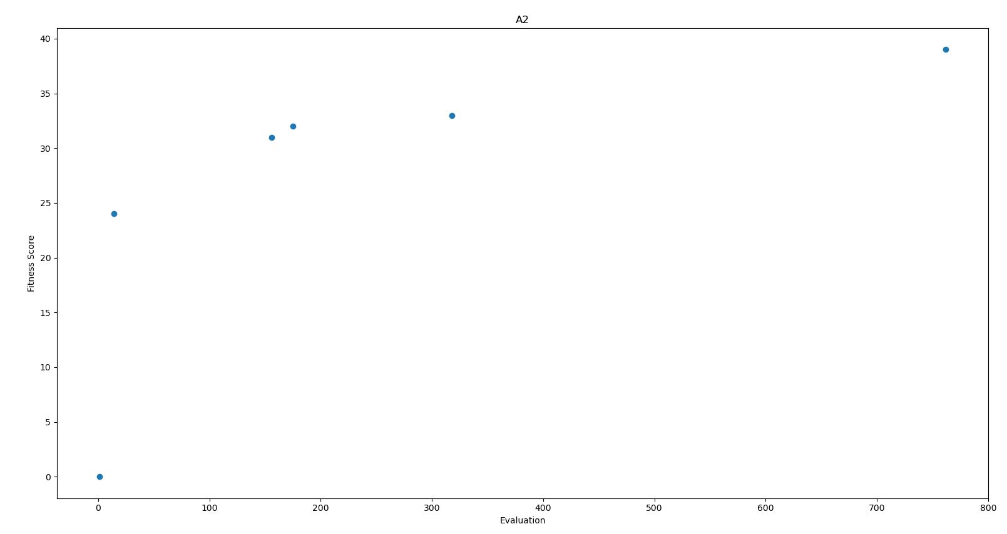

Graph for problem set a3: 